Integrated Analysis of Tumor Size and Racial Differences in Triple Positive Breast Cancer
INTRODUCTION:
Triple positive breast cancer is often a less frequently studied but clinically significant group in which tumor express all three receptors. These show unique biological behavior, and asked how tumor size and race together shape outcomes and where size breakpoints create sharp changes in risk and treatment benefit. Studied 24,653 women in SEER (2010-2022) to analyze the tumor size and race interaction with treatment and the insights. Previous research has established that larger tumors generally cause worse survival, and that systemic therapy improves outcomes, but few studies have examined absolute survival within defined time frames or validated whether standard proportional hazard assumptions hold. Since hazard ratios can obscure real-world interpretation, we emphasized time-based measures that provide clinicians and patients with more intuitive survival estimates across subgroups.
METHODS:
The study of designed on cohort of 23,845 women from SEER(2010-2022) to analyze the tumor size and race interaction with treatment and the insights. Tumor size served as the main analytic variable and was available in two SEER fields (“Over-time” and “Summary”). Missing values were cross filled to create a complete numeric variable. To decide whether tumor size should be treated as continuous or categorical, a non-linearity test was performed. The association proved nonlinear (p < 0.05), so tumor size was grouped following AJCC T-stage (T1a/b/c,T2,T3,T4) cutoffs: 0–5 mm, 6–10 mm, 11–20 mm, 21–30 mm, 31–50 mm, 51–100 mm, and >100 mm.
Descriptive statistics summarized baseline characteristics (frequencies for categorical variables, medians for continuous). Survival was first estimated using the Kaplan-Meier (KM) method and compared with log-rank tests (p < 0.05). To move beyond hazard ratios which assume proportional risks over time. we used Restricted Mean Survival Time (RMST) at 36 and 60 months as the main outcome. RMST represents the average survival up to a fixed time point, offering an intuitive measure of absolute benefit.
Five major treatment contrasts were examined throughout the analysis: “Both vs Chemo only”, “Both vs None”, “Chemo only vs None”, “RT only vs None”, and “Chemo only vs RT only”. Initial unadjusted RMST comparisons estimated survival differences and number needed to treat (NNT) by tumor size and race. However, unadjusted estimates can be biased because treatment choice depends on patient factors (e.g., age, comorbidity, socioeconomic status).
To correct for this bias, we applied Inverse Probability of Treatment Weighting (IPTW) using a propensity score model to control randomization. Each patient was weighted inversely to their probability of receiving treatment, producing balanced pseudo-groups. To enhance robustness, we then used Augmented IPTW (AIPW) a doubly robust approach that remains valid even if either the treatment or outcome model is slightly mis specified. This ensures more reliable estimates of treatment effects.
We compared Gradient Boosting Machine (GBM) and logistic regression for generating propensity scores. Logistic regression performed better (higher effective sample size and improved balance across covariates), so it was used in the final model during IPTW. Covariates were chosen through Decision Curve Analysis (DCA), which confirmed that including them improved model accuracy compared with treating all or no patients.
To validate results, we used a Causal Forest model, an advanced machine learning approach that estimates treatment effects across subgroups. The causal forest results strongly agreed with IPTW (correlation 0.96) and AIPW (correlation 0.77), confirming high model stability and reliability.
The primary endpoint was overall survival (death from any cause). Cause-specific survival was also tested but had wide confidence intervals due to fewer events; still, effect direction matched overall survival in 89.7% of cases (correlation 0.905), supporting consistency.
Overall, this stepwise analytic approach from KM to Causal inference was designed for real world treatment with minimizing bias from non-random treatment assignment. IPTW provides interpretable population level effects, whereas AIPW was designed for robustness and these methods ensure the results are genuine clinical effects rather than statistical artifacts.
RESULTS AND CLINICAL INTERPRETATIONS:
For the total of 23,854 women, it was observed that the overall survival of 85% over the course of the study. The median follow up was 61 months (IQR= 28-98 months). Tumor size displayed a right-skewed distribution, with 58 % of tumors measuring ≤30 mm and approximately 12 % exceeding 50 mm. The most common category was 11-20 mm (T1c, 31.6 %), followed by 21-30 mm (T2a, 23.1 %) and 31-50 mm (T2b, 17.4 %). Very large tumors (>100 mm, T4+) were rare, comprising less than 1 % of the cohort.
From the log-rank test of tumor size, comparisons between the 6110 mm and 11-20 mm groups were not statistically significant, whereas all other tumor size comparisons showed significant differences in survival. Across races, overall survival followed the pattern Non-Hispanic Asian/Pacific Islander (NHAPI) > Hispanic > Non-Hispanic White (NHW) > Non-Hispanic American Indian/Alaska Native (NHAIAN) > Non-Hispanic Black (NHB). In the interaction between tumor size and race, the hazard for NHW and NHAPI patients increased gradually with tumor size, while for NHB and NHAIAN patients the hazard accelerated more sharply, reflecting a steeper risk slope.
Traditional Cox regression and log-rank tests summarize relative hazards, which can be misleading when the proportional hazards assumption is violated or when survival curves cross both of which were observed in our data across tumor size and race strata. Therefore, the analyses leading to the final doubly robust (DR) RMST results incorporated appropriate covariates, modeling strategies, and validation procedures as described in the Methods section. The following section presents the interpretations from the final DR-RMST analysis examining tumor size*race interactions and the LATE analysis performed on tumor size to capture size-dependent treatment effects.
Interpretations:
Tumor size Inflection zones: While survival naturally declines with increasing tumor size, this decline is not linear. The data reveal sudden jumps in survival benefit between size bins specific points where treatment impact rises sharply. These inflection zones represent size ranges where therapy begins to make a markedly greater difference compared to no treatment. The first inflection zone occurs around 21-30 mm, followed by a second zone at 51-100 mm. With the increase in bins the treatment benefit increase Before these ranges, treatment provides steady but modest benefit; however, once tumors cross these thresholds, the survival gain from chemotherapy increases abruptly, showing how treatment becomes substantially more impactful. Figure 1 visualizes this pattern illustrating how the ΔRMST for chemo vs none rises sharply beyond the 20 mm mark, reflecting these inflection-driven shifts in treatment effect.
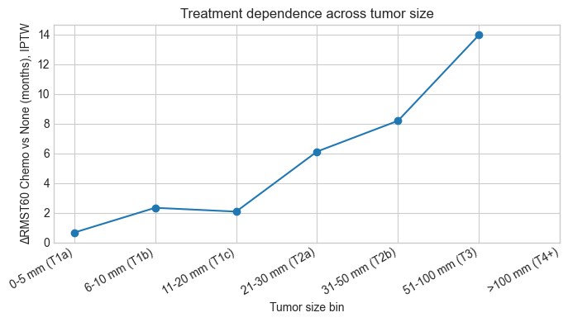
Figure1: ΔRMST chemo vs none with the IPTW values.
These tells how important for the patient falling in a particular bins make periodic change with the treatment. To identify the exact inflection points, a decision tree analysis was performed, which identified major partitioning around 18.5 mm and 39.5 mm with minimal error. However, the overall model fit (low R² and relatively high RMSE) suggests these should be interpreted as zones of transition rather than fixed cut-points, representing points where treatment begins to yield disproportionately higher benefits.
Race-Tumor size interaction and Disparity Amplification: Across all treatment arms, the relationship between tumor size, race, and survival showed clear interaction effects the magnitude and slope of treatment benefit differed notably among racial groups as tumor size increased.
In Non-Hispanic White (NHW) and Non-Hispanic Asian/Pacific Islander (NHAPI) patients, survival gains from treatment rose progressively with tumor size across all contrasts.
- For example, in Both vs None and Chemo vs None, ΔRMST increased steadily from small to intermediate tumors and peaked between 31–50 mm before plateauing.
- In Both vs Chemo, the incremental gain from adding radiation remained modest but consistent, indicating stable responsiveness to combined therapy.
By contrast, Non-Hispanic Black (NHB) and Non-Hispanic American Indian/Alaska Native (NHAIAN) women showed a sharper, earlier escalation in risk and a less uniform treatment-response curve.
- In these groups, treatment benefits (particularly in Chemo vs None and Both vs Chemo) spiked abruptly once tumors exceeded 30 mm, suggesting that therapeutic dependence intensifies earlier in the disease course.
- Despite strong absolute ΔRMST gains, their treated survival levels remained lower than in NHW or NHAPI patients of the same size, pointing toward residual outcome gaps likely driven by treatment delays, incomplete regimens, or underlying biologic aggressiveness.
Hispanic women displayed an intermediate pattern: survival remained on par with or slightly better than NHW in tumors up to 30-40 mm but declined more steeply beyond 50 mm, reversing their earlier advantage.
This shift was evident in Both vs None and Chemo vs RT contrasts, where incremental benefit diminished despite therapy, implying that late-stage disease in this group may reflect decreased treatment responsiveness or later-stage presentation. As tumor size increased, the corresponding changes in ΔRMST demonstrated how the magnitude and direction of treatment effect evolved nonlinearly with the most rapid gains occurring around the 30–50 mm range, followed by tapering in larger tumors. Overall, the hierarchy of benefit consistently followed the pattern Both > Chemo only > RT only > None, confirming that survival advantage rises with treatment intensity, but the degree of improvement and the size threshold at which it manifests vary by race.
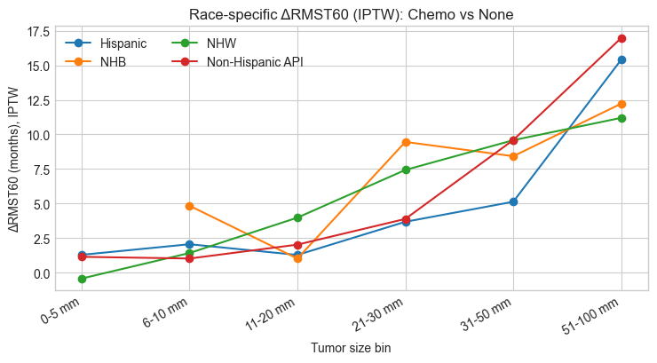
Figure: 2 Chemo vs None race specific changes in RMST
From the plot, overlapping patterns are observed among most racial groups. Since this is not a survival curve but rather a depiction of changes in RMST between treatment arms, such overlap reflects similar overall treatment trends rather than identical survival outcomes. The general behavior aligns with the earlier interpretation treatment benefit increases with tumor size but in a nonlinear fashion. Across contrasts, NHB patients consistently exhibited sudden spikes in treatment effect, indicating earlier and sharper therapeutic dependence compared to other groups. The NHAIAN group is not displayed here due to limited sample size; however, analyses show wider confidence intervals and poorer survival estimates, suggesting both statistical instability and worse baseline outcomes in this subgroup.
Other Useful clinical Interpretations:
  - Chemotherapy benefit: This is the most robust conclusion, and it is observed consistently in unadjusted K-M contrasts, Cox models, RMST analysis and parametric survival models. A Weibull AFT model, for instance, estimated that chemotherapy more than quadrupled survival time on average (time ratio ~4.6) , and a doubly robust analysis likewise confirmed large treatment effects.
  - Survival Disparity patterns: Some of the nuanced racial patterns were tested with validation and bootstrap sensitivity checks. These checks observed statistical reliability of largest gaps. For example, the API survival edge at 21–50 mm, the Hispanic survival reversal between 31–50 and 51–100 mm, and the Black outcome collapse beyond 100 mm all remained significant under resampling.
  - Multimodal Treatment Effects: The benefit of adding radiation to chemo in tumors is observed repeatedly and with tumor size increase the confidence increases. The significance as tested on adjusted p-values observing results in RMST and KM probabilities making it trustworthy.
  - Early tumor control remains conclusive: Tumors less than 20mm showed minimal absolute gain.
  - Methodological and interpretive considerations: Results in smaller subgroups particularly NHAIAN patients and extreme tumor sizes (>100 mm) should be interpreted cautiously due to limited sample size, wide confidence intervals, and potential selection bias favoring fitter patients for aggressive therapy. While such findings consistently support the direction of benefit (any treatment better than none), the magnitude of effect may be overstated. Additionally, because this is an observational study, residual confounding from unmeasured health or access factors cannot be fully excluded, even though weighting and sensitivity analyses confirm the robustness of the main conclusions.

